Winter 2022

Ski Calendar

Date | Place | Participants
January 15 | Blue Valley | (6 to 12 years old)
January 22 | Saint-Sauveur | (13 to 25 years)
January 29 | Saint-Bruno | (6 to 12 years old)
February 5 | Montcalm | All
February 12 | Morin Height | (13 to 25 years)
February 19 | Mont Habitant | (All)
February 26 | Mont Rigaud | (6 to 12 years old)
March 5 | Mont Gabriel | (13 to 25 years)
March 12 | The Reserve | (All)
March 19 | Mont Blanc | (13 to 25 years)
25-26-27 March | Mont Tremblant | EXPERIENCED

Equipment rental:
For those who do not have equipment, you must rent with us. No rental will be made in the mountains.
Please note that the fitting days are from December 7 to 9 in the evening.

It is important to make an appointment with Alexandre St-Arnaud at: alexandre@aveugles.org by email. The rental of equipment, is done at the service point of 6280 39e avenue (our leisure garage).

Rates
A day of skiing/boarding | $65
Stay at Mont Tremblant | $295
Equipment rental for the winter | $50

Meeting point
Place | Departure | Return
Building Coup d'Oeil  2585 Bennett Avenue,Montreal | 8 a.m. | 5:30 p.m.
Decathlon  1600 Blvd Le Corbusier, corner St-Martin | 8:30 a.m. | 5 p.m.

* For the January 29 outing (Mont Saint-Bruno) *Departure will be from Laval
at 8 a.m. and montreal at 8:30 a.m. / Return to MTL at 5 p.m. and Laval at 5:30 p.m.

* For the weekend at Mont Tremblant *

The departure will be from Montreal at 7:00 p.m. and laval at 7:30 p.m.
The return will be in Montreal at 17:30 a.m. and in Laval at 17:00 a.m.

General Information

Registration: November 10 to December 3 2021

Please send us registrationand payment:

Online registration: www.jeminscrismaintenant.com/loisirsfaq
By mail: 5112 Bellechasse Street, Montreal, Quebec H1T 2A4
By fax: 514 254-5079
By email: alexandre@aveugles.org

- Make sure all records (information, activities, health and medications) are complete.

- The Vaccination Passport will be MANDATORY and ASKED in the mountains for young people aged 13 and over

- It is important to pay the fee at the time of registration or to make an agreement withthe management to ensure your place in the activities.

- Our waiting time on departure is limited to 10 minutes.

- No refunds will be given without 2 weeks' notice. In the event of a cancellation of the F.A.Q., the activity will be refunded, credited or replaced.

- A 20% discount will be applicable to the second additional child/youth of the same family (brother and sister).

- As the activities are primarily aimed at participants with visual disabilities and their age group, siblings of participants will be registered if the participant limit is not reached by the registration deadline. We will track your registration after the deadline in the order we receive the cards.

Contact Us
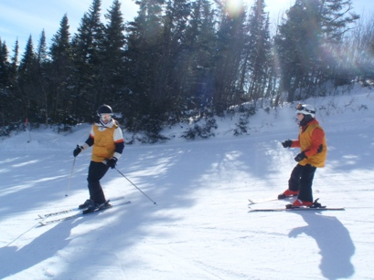
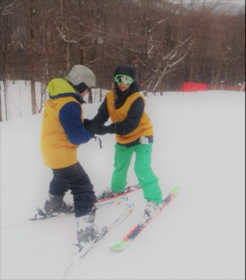

The Leisure Team
Fondation des Aveugles du Québec
Tel.: 514-259-9470, p. 229
alexandre@aveugles.org
steve@aveugles.org

