

WINTER 2023

Recreational Calender



**CROSS-COUNTRY SKIING AND OUTDOOR ACTIVITIES aT maisonneuve PARK**

Sunday January 22nd, 2023 – 10 h 00 to 4 h 00

For kids, teenagers, and 18 to 25 years old.

Start the year with a beautiful day of cross-country skiing, snowshoeing

and many more activities with our guides!

Fun is guaranteed!  
**Meeting point: 6055 41e Avenue, Montreal, H1T 2T7**

**30 $**



**QUEBECCERS ASSOCIATION TO THE PARENTS OF KIDS WITH VISion HANDICAPS**

28 and 29 January 2023 *– 9 h to 4 h 30*

A full day of activities organised by the association.

For more information, please communicate by phone at: **450-465-7225.**

**ICE FISHING + LUNCH INCLUDED**

Sunday February 12th, 2023 – 10 h 00 to 4 h 00For kids, teenagers, and 18 to 25 years old.

Canada is one of the most popular places on earth

for ice fishing amateurs, the Foundation is inviting you to come and

participate to our wonderful ice fishing day at fishing!

Bring your warm clothes.

**Meeting point: 6055 41e Avenue, Montreal, H1T 2T7**

**45 $**



**_______________________________________________________**

**snow tubing at mount avila**

Sunday February 26th2023 – 10 h 00 to 4 h 00

For kids, teenagers, and 18 to 25 years old.

Rafting and tube sliding.

Bring your lunch and warm clothes!

**Meeting point: 6055 41e Avenue, Montreal, H1T 2T7**

**40 $**



**week-end at camp edphy**Friday to Sunday, March 3rd to 5th 2023   
Departure (Friday March 3rd) 6 h 30 PM  
Arrival (Sunday March 5th) 3 h 30 PM  
For kids, teenagers and 18 to 25 years old.

Campfire, marshmallows, sausages, snowshoeing, slides,

games in the forest, and more.

**Meeting point: 6055 41e Avenue, Montreal, H1T 2T7**  
**250 $**

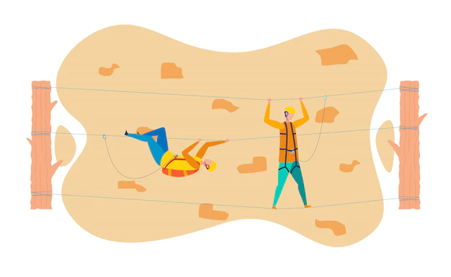

**HIKING AND ZIPLINES**

**Sunday March 19th, 2023 – 8 h to 4 h**

A guided activity that starts with a 1,3 km hiking

to reach the 2 ziplines of 900 and 650 meters!

Courageous or not, you are welcome!

**Meeting point: 6055 41e Avenue, Montreal, H1T 2T7**

**50 $**

**SUGAR SHACK LALANDE AND FAMILY**

Sundar April 2nd, 2023 – 11 h to 5 h

One of our classics.

Come dine with us with your family!

Little farm, taffy, dancing to old songs, carriage tours, our guides team and

Many more surprise is waiting for you!

**Meeting point: 6055 41e Avenue, Montreal, H1T 2T7**

**35 $**

**Contact us**

MCj04105410000[1]MCj03967980000[1]

Sandrine Courtois

Adjointe à la programmation

Fondation des Aveugles du Québec

Tel. : 514 259-9470, p. 229

Cell.: 438-885-0902

[sandrine@aveugles.org](mailto:sandrine@aveugles.org)

[steve@aveugles.org](mailto:steve@aveugles.org)